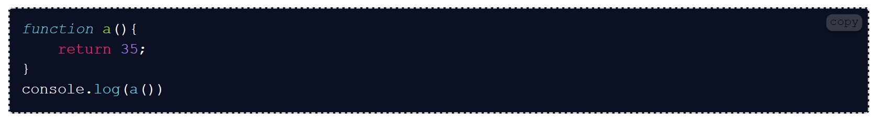
R:35
R:8
R:6
R: 3,9

R:10,40
R: 4, undefined
R:10,3,30.-
R:2,5,8,11,indefinido
R:0,1,2,3,4,5,6,7,8,9,0,1,2,3,4,5,6,7,8,9,0
R:Indefinido-.
R:indefinido.
R:10

R:15,15, indefinido.

